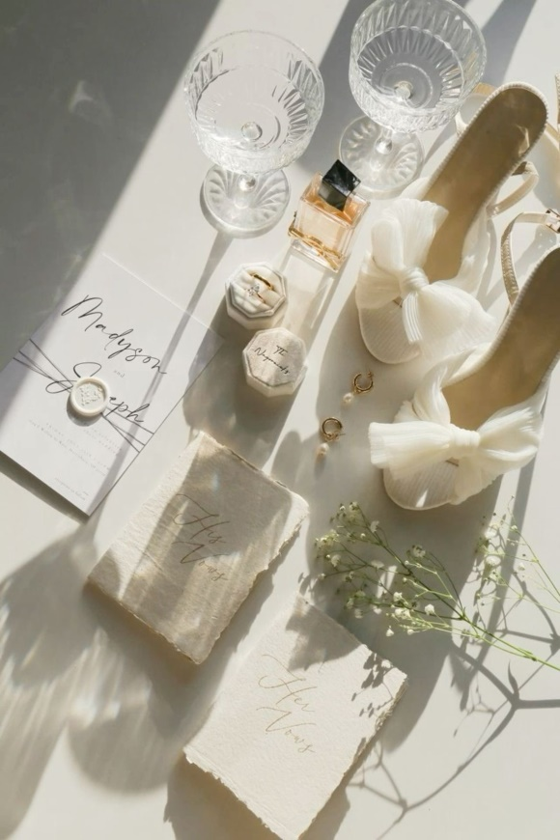

Tips for brides

1. Should I have a rehearsal or not? The choice is yours. If you want to see how you will look on your wedding day, all this needs to be done in the same full volume as for the celebration itself. Many brides do a trial makeup to make a final decision, as well as just get used to a new look.

2. Eyebrow correction is best done two to three days before the wedding. Before that, try not to pluck your eyebrows yourself — trust a professional. Eyebrows should be modeled correctly to make the facial features more harmonious and complement the image.

3. Go to a cosmetologist if necessary. Do it in advance, 1.5-2 weeks before the wedding or a month before. After skin moisturizing procedures, the makeup will look much better.

4. Do not abuse the solarium. A light golden tan looks beautiful, but too dark skin is rather ridiculous. You can start visiting the solarium a month in advance and it is better to stop at least a week before the wedding so that the redness goes away. I would advise you to forget about self-tanning at all: you definitely don't need divorces and orange skin color on your wedding day.

5. I advise you to buy:

* matting wipes to periodically refresh your face and the groom's on the wedding day (so that the skin does not shine in the photo);
* beautiful transparent or colored lip gloss to fix your makeup during the day;
* loose powder and a brush.

6. Do not experiment with exotic remedies on the eve of the wedding, to minimize stress to your skin. Also, try not to drink too much liquid and do not eat spicy and fatty foods.

7. Get enough sleep! It probably sounds strange, but often the last preparations are delayed until late at night, and pre-wedding experiences do not allow you to sleep, and you need to get up very early. Hence the bruises under the eyes, fatigue, but there is a very long and emotional day ahead. Therefore, think about and prepare everything in advance, do not leave anything at the last moment so that you have time for a sound healthy sleep

8. Be sure to wash your hair at night and dry it. It is better not to apply oils to damp hair. The hairstyle lasts much longer on dry hair.

9. It is desirable that the bride's preparation takes place in a calm atmosphere, so try to make sure that only you, the makeup artist or the stylist are in the room (the exception is the photographer). Don't let anyone distract you, including the phone. The bride does the makeup together with the master (looks where she needs to, etc.).

Use these tips to be and feel irresistible on your wedding day. May this day be remembered as one of the happiest!